**Intro to SQL Server Assignment**

**Problem Statement:**

Consider yourself to be Sam, who is a student at a prestigious university. You have enrolled for the SQL course and it is your first semester.

Tasks to be done:

1. Install MS SQL Server

Answer:

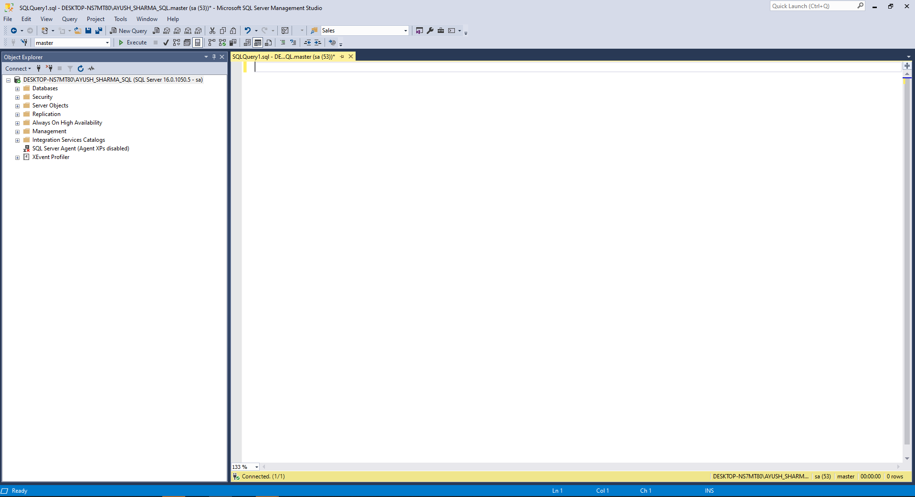

2. Learn the basics of Structured Query Language

Answer:

To show that I have learnt the basics of SQL, I am presenting two basic queries on the following table and their output:

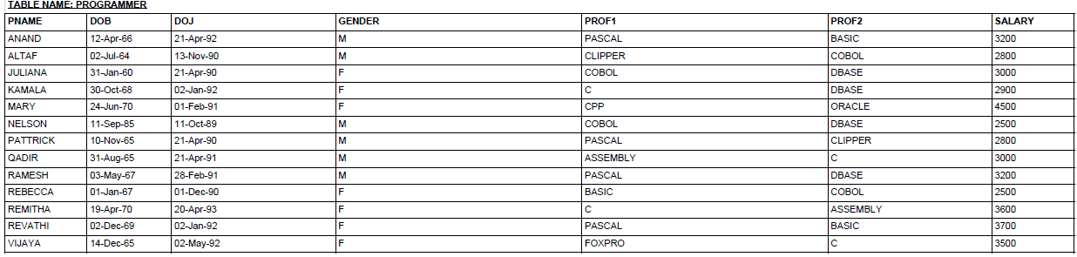

Query 1: Select * from dbo.Programmer; --To show the whole table

Output:

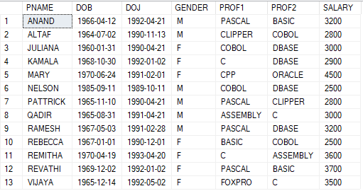

Query 2: Select * from dbo.Programmer where GENDER = ‘F’ and Salary > 3000; --To show all the columns for female programmers with salary more than 3000.

Output:

